Annual Report
2023-2024



Kulala Street
Thirunainarkurichy
Ammandivilai Post
Kanyakumari District
Tamil Nadu – 629 204.

From the Director

It is with great pleasure I am submitting the annual report of Centre for Social Development for the year 2023-2024. CSD in its 32nd year of formation rededicates with the missionary zeal of improving the socio-economic status of the rural poor weaker section and socially excluded people of the community.

During the last years we have undertaken lot of activities and programs for the rural poor, artisans, women, children, youth and adolescents and socially excluded people of the community in health, sanitation, education, village industries development, holistic development of the villages, agricultural development etc. We are having transference in all of our activities.

We got ISO 9001 – 2008 for the quality services rendered by us to the target community. We are arranging for the welfare activities of the staff during the coming year.

I take this good opportunity to extend my thanks to the General Body members for their interest appropriate guidance shows towards the CSD’s activities and the development of the communities which we have interested to develop.

I am thankful to the financial supporters extended in the form of projects by Department of Science and Technology, New Delhi, DSIR, New Delhi, TANSACS, Chennai, NABARD, Chennai, KVIC Mumbai, IOCL, Chennai, RuTAG-IITM, Chennai, TANSACS, Chennai etc. for their timely financial supports for us for implementing our projects.

I gratefully acknowledge the committed services rendered by the full time and part time staff, expert’s indifferent fields, Project consultants and volunteers of CSD, the committee members of CSD etc.

I am very much thankful to our friends, well-wishers, advisers, consultants, and different Government department heads, NGOs, Banks and supporters individually and collectively for all the co-operation extended to us for our social actions.

Dr.P. Bagavatheeswaran
Director.

About our Organization

Centre for Social Development was registered as a society on 11th August 1992 under the Tamil Nadu Societies Registration Act 1975. The founder of our organization is Dr.P.Bagavatheeswaran and also the Director. From the inception onwards CSD has actively contributing to socio-economic development of the target groups in Tamil Nadu especially in Kanniyakumari, Thiruvallur, Tuticorin , Tenkasi and Tirunelveli districts.

Vision

Preserving and promoting the local indigenous cultural heritage, harmony and artisan skills of the people and empowering socio-economically the weaker sections and discarded people of the society towards an egalitarian society.

Mission

Facilitating the grassroots, dalits, artisans, orphans, affected and infected children, rural youth both male and female, women in distress of their dilapidated conditions, rehabilitate and empowering them both socially and economically through specialize staff team and suitable activities.

Objectives

- To improve the health standard of people, safeguarding hygiene and environment safety.
- To rehabilitate the weaker section, depressed communities, socially excluded, artisan, child labor and bonded labor.
- To develop and establishing viable and sustainable income generation activities using locally available resources.
- To provide infrastructural facilities with effective construction techniques to the rural poor and depressed communities.
- To conduct community development programs for tribal, youth, schedule caste and differently-abled people.
- To provide care and support services to the needy people.
- To identify the potential entrepreneurs among the rural people/youth and guide them towards socio economic development.
- To help the entrepreneurs for the establishment of their own sustainable units.
Target Group

CSD is concentrating on the economically weaker sections of the society viz.

  - Scheduled castes / tribal.
  - Landless laborers and marginal farmers
  - Village artisans / crafts person
  - Adolescents, Youth, Women and children
  - Migrants, Female Sex Workers (FSW), Men Sex with Men (MSM)
  - Minority communities
  - Potential entrepreneurs
  - Widows, destitute, old age people etc.
  - PLHA and HIV affected and infected.
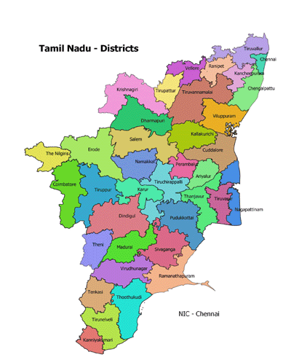
Working Area Map
Kanyakumari
Tirunelveli

Addresses of CSD’s Branch Offices:
- CSD, CSD,
20/47 Salt Merchant compound Thumbavilai.
Near Thuckalay Bus stand, Thalakulam PO,
Thuckalay & P.O. Kanyakumari District.
K.K. Dist - 629 175.

- CSD CSD
‘0’ Point Mahendrapuram,
Pechiparai& P.O, Radhapuram P.O
Kanyakumari District. Tirunelveli district.

Director’s Awards towards CSD’s achievement.
- Best Rural Artisan Award.
- Man of Winner Award.
- Anna Award.
- Annai Indira Gandhi Award &SevaiChemmal Award.
- Bharatharatna Dr. M.G.R. Award.
- Jambavan Award.
- Bharathi Award.
- Annai Therasa Award.

Thanks to Dignitaries

.
Dr. Sujata Chaklanobis - Advisor , DSIR – DST, - New Delhi
Dr.Ranjeet Bairwa - Scientist, DSIR, New Delhi.
Dr.Rajinder Singh - Scientist, DST-NCSTC, New Delhi
Dr. Indu Puri - Scientist DST, New Delhi.
Dr. Rajni Rawat - Scientist, DST, New Delhi
Dr. Rakesh Sah - Scientist, DST, New Delhi
Dr. Anuradha Pughat - Scientist, DST, New Delhi.
Dr. Konga Gopikrishna - Scientist, DST, New Delhi.
Dr. Abhijit Deshpande - Scientist, IITM, Chennai
Shri. Ram Kishore - CSR Head, IOCL, Delhi.
Thanks to Resource Persons
Dr. S.Anandhakumar - Scientist, NIIST, Trivandrum.
Dr. T.K Mukhapodayay - Retd. Scientist, CGCRI Calcutta.
Mr.Yad Ram - Rtd. Technical Officer, CGCRI. Khurja
Dr. Jeyanandan - Rtd. Veterinary Doctor,
Goat Research Station, Kerala.
Our Appreciable Master and Technical Team

Dr. P. Bagavatheeswaran - Pottery Expert
Dr.A.D. Shobana Raj - Environment Scientist.
Mr. Laxmikant - Pottery Technician
Mr.P. Maharajan - Ceramist,
Mrs. R. Baby LeelaBai - EDP Trainer
Mrs.R. Mary Stella - SHG Trainer
Mr.S.Arul Monoharan - Youth Trainer.
Er.B. Karthik - Research Scholar.
Our Sincere Bankers

Union Bank of India - Vadasery,Nagercoil and Kadiyapattanam.
Bank of Baroda - Nagercoil
Indian Bank - Muttom
State Bank of India - Thingal Nagar
Central Bank of India - Aloor
ICICI Bank - Marthandam and Nagercoil
Our networking with

TNVHA - Tamil Nadu Voluntary Health Association.
SAM - Social Action Movement
INN - Indian Network of NGOs – HIV/AIDS Network.
IHN - Initiatives of HIV/AIDS – Net.
CACL - Campaign Against Child Labour
cHAI - Consortium on Health Awareness in India.

HIGH LIGHTS DURING THIS YEAR 2023 – 2024
1. HIV/AIDS Prevention and Care Continuum changed the
behavior of HRGs and improve the health status.

Achievement for the year 2023-224
Under this project CSD has conducted targeted intervention among Female Sex Workers (FSWs) and Men having sex with men (MSMs) in Kurunthencode,
Thuckalai, Munchirai, Killioor, and Melpuram Blocks of Kanyakumari District with the help of TANSACS, Chennai. This is a continuous project. 700 FSWs and 500 MSMs were identified and rendered services to them.
Achievement from April-2023 to March-2024
Sl.No | INDI  CATORS |  | April | May | June | July | Aug | Sep | Oct | Nov | Dec | Jan | Feb | March | Total
1 | ICTC | FSW | 64 | 56 | 104 | 64 | 72 | 142 | 44 | 112 | 114 | 112 | 96 | 186 | 1166
1 | ICTC | MSM | 46 | 80 | 82 | 80 | 55 | 40 | 51 | 71 | 100 | 51 | 59 | 70 | 785
2 | RMC | FSW | 105 | 131 | 172 | 111 | 97 | 235 | 88 | 75 | 137 | 103 | 108 | 179 | 1541
2 | RMC | MSM | 100 | 105 | 126 | 101 | 84 | 123 | 90 | 96 | 112 | 59 | 16 | 69 | 1081
3 | VDRL | FSW | 64 | 56 | 104 | 64 | 72 | 142 | 44 | 40 | 114 | 112 | 96 | 93 | 1001
3 | VDRL | MSM | 49 | 80 | 82 | 80 | 55 | 40 | 51 | 112 | 100 | 51 | 59 | 36 | 795
4 | New Identification | FSW | 0 | 0 | 10 | 5 | 14 | 3 | 7 | 3 | 1 | 0 | 7 | 8 | 58
4 | New Identification | MSM | 13 | 14 | 9 | 5 | 6 | 4 | 5 | 1 | 4 | 3 | 4 | 6 | 74
5 | Condom  Distribution | FSW | 14160 | 15873 | 11128 | 12766 | 12135 | 7903 | 0 | 0 | 0 | 2805 | 5953 | 7082 | 89805
5 | Condom  Distribution | MSM | 9992 | 11016 | 9399 | 8896 | 8553 | 4964 | 0 | 0 | 0 | 1643 | 3712 | 5102 | 63277
6 | Counselling | FSW | 68 | 69 | 89 | 78 | 73 | 78 | 69 | 118 | 73 | 90 | 66 | 75 | 946
6 | Counselling | MSM | 28 | 36 | 38 | 32 | 46 | 39 | 41 | 45 | 39 | 44 | 66 | 59 | 513

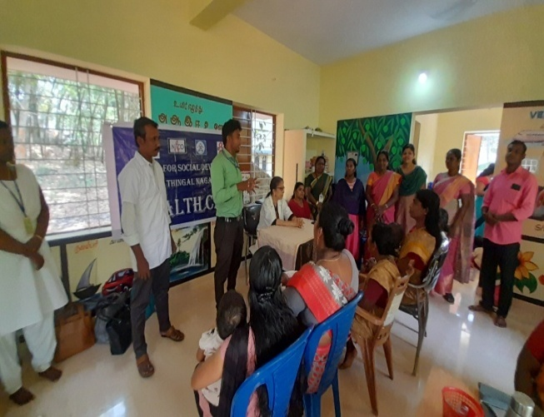
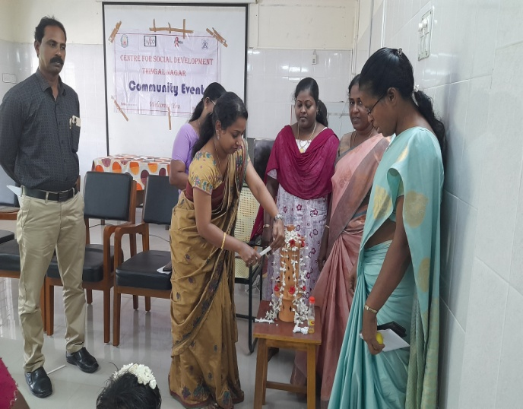
The core group community people to be highly vulnerable for STI and HIV infections due to their unsafe sex behaviors. Ten peer educators, four outreach workers, a Counselor, a Monitoring and Evaluation officer and a Project Co-ordinator worked in this project. This project was sanctioned and started from 01.04.2012 onwards.
Community event Health Camp

Special events

S.No | Name of the event | Date of event | Place of event | No. of participants
1 | Advocacy meeting | 30/08/2023 | Methukummal | 16
2 | Health Camp | 15/09/2023 | Udaya Marthandam | 90
3 | Community Event | 26/09/2023 | Padmanabapurm Head Quarters Hospital,Thuckalay | 78
4 | Advocacy meeting | 27/11/2023 | Colachel | 20
5 | Health Camp | 28/02/2024 | Thalakulam | 71
6 | Community Event | 07/03/2024 | Padmanabapurm Head Quarters Hospital,Thuckalay | 82
7 | Health Camp | 13/03/2024 | Kattavilai | 75
8 | Advocacy meeting | 21/03/2024 | Monday Market | 20

Attending training programme

S.No | Name of the training | Date | Place | No. of participants
1. | SOCH Training | 26.10.2023 to 27.10.2023 | Mamalla resort, Mahabalipuram | 2(M&E and Counsellor
2. | PM training | 09.12.2023 to 13.12.2023 | Hotel Deluxe, Koyambedu. | 1 (PM)
3. | M&E and Accountant training | 19.12.2023 to 23.12.2023 | Hotel Deluxe, Koyambedu | 1(M&E)
4. | HSS, HRG training | 28.12.2023 to 29.12.2023 | Hotel Vestin Park, Chennai | 2 (PM and Counsellor)

- STATUS IMPROVEMENT OF SC PEOPLE.

This project has been formulated to help the SC people living in Thalakulam village in Kurunthencode Block of Kanyakumari district. They are imparted with necessary information and skill so as to prepare them for better income generation. This project was sanctioned by Department of Science and Technology, New Delhi. The project activities have been launched successfully with the help of the community people, local Panchayat members. Under this project, SHGs formed and regular meetings, discussions, conducted to evolve their interest. The major objective of this project is to upgrade the existing status of the pottery industry and train the SC people in the advance technology of clay body formation, methods of fabrication, designing, firing techniques, marketing etc. . The overall effort is to equip the SC people with adequate technical skill and to help them in availing financial assistance to convert them as entrepreneurs in the concern pottery trade. The beneficiaries of this project are 30 SC people selected from Thalakulam village. The project was started from 1st April 2022 onwards. The three batches training was completed.

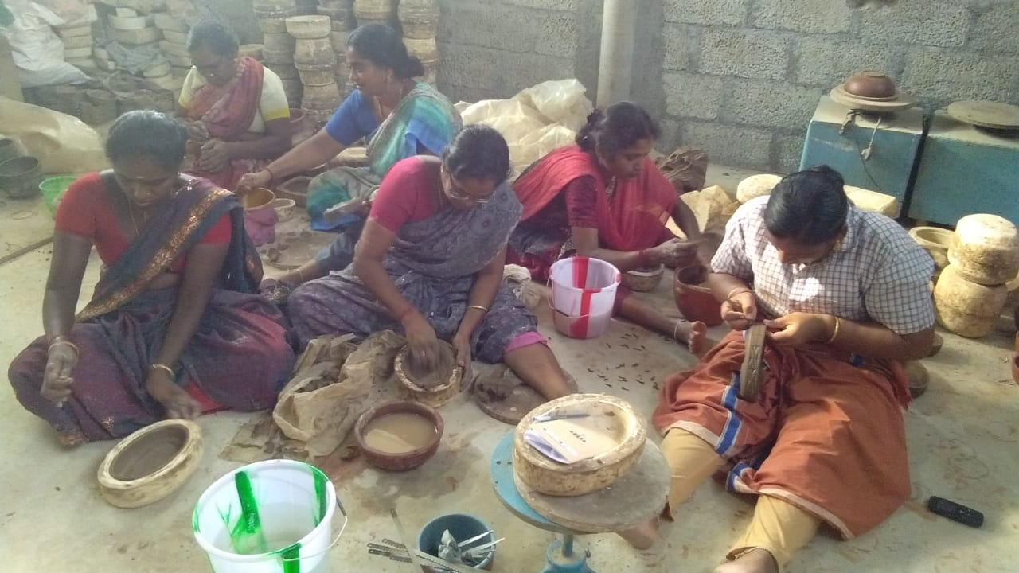
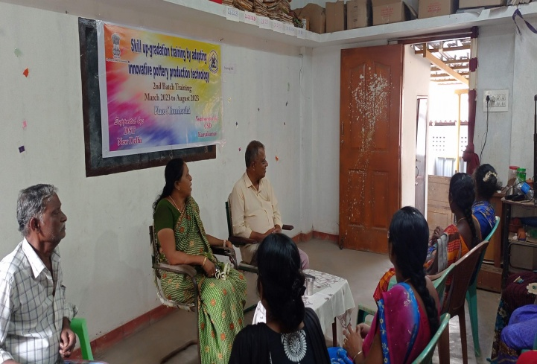
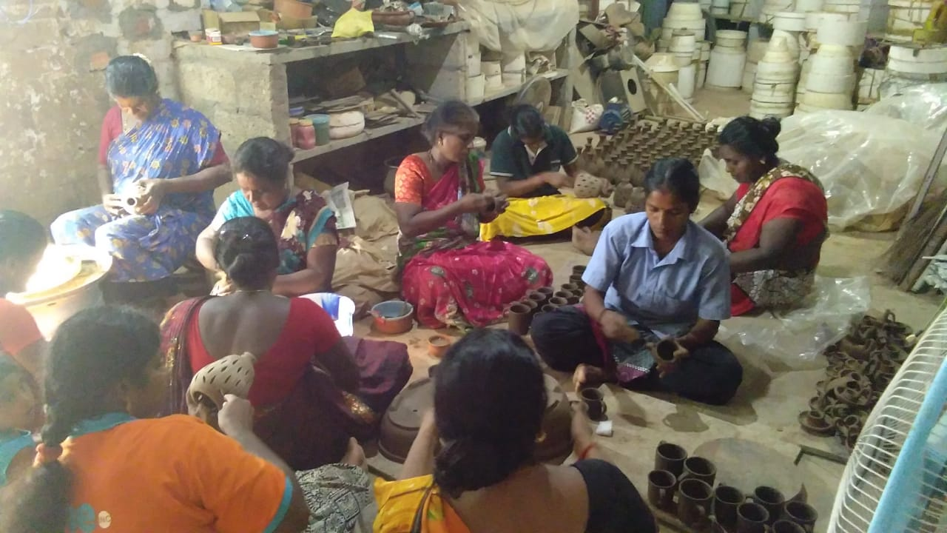
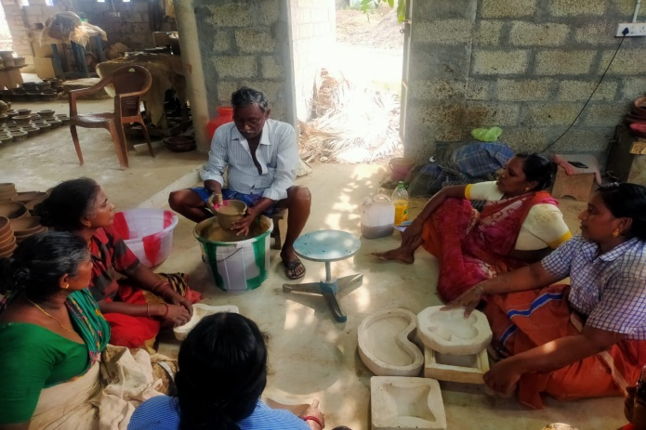
Inauguration programme 2nd batch training – cutting method

Products fabricated by casting method Finishing the products.

Outcome
- 30 SC people trained in modern technology of pottery manufacturing.
- The knowledge level of the SC people had increased towards S&T application in the particular trade of Pottery product manufacturing. (Modern clay processing, products fabrication, kiln firing etc).
- Establishment of a sustainable modern pottery production unit being run by the beneficiary group.
- Fabrication of pottery products for Inland and export marketing.
- Initiated export marketing.
- Designed products fabrication which has market acceptability to all the segments of the consumer.
- Increased earning at an average from Rs 120 to Rs 225- Female and from Rs. 300 to Rs. 500/- Male
- CHARITABLE ACTIVITIES
Distribution of relief materials during Flood
CSD has involved in undertaking awareness and relief activities during the flood and COVID - 19 pandemic period. We have conducted awareness programme among the Scheduled caste, tribal and potters communities in Kanyakumari and Tirunelveli Districts.

We have covered 4 villages by distributing the raw materials and infrastructure support to the needy potters community. Small gathering was arranged among the potters community and they were made aware of the precautionary measures to be adopted during flood. By this programme we could cover the beneficiaries of village artisans and economically weaker section. For undertaking this activity donation was floated from a UK based philanthropist Mrs. Kate Malone & her family along with our own contribution.

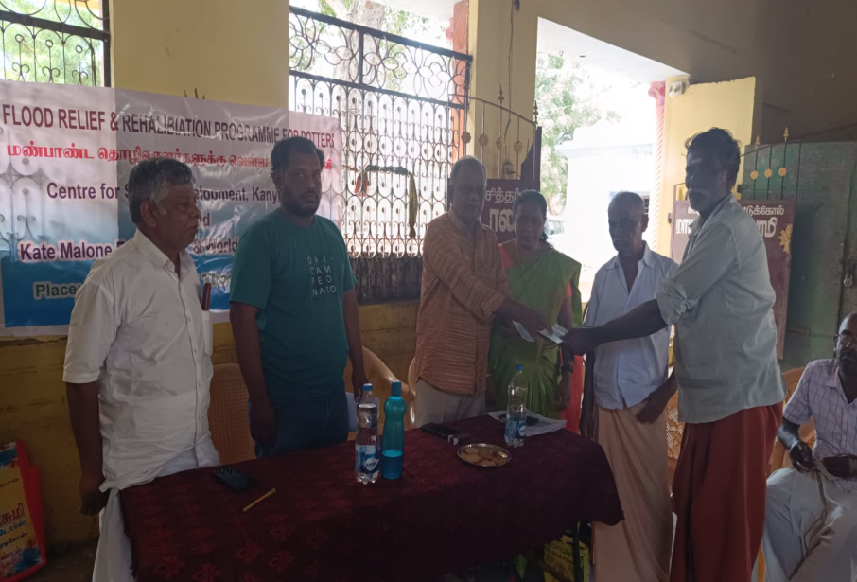

- SCIENCE COMMUNICATION AND POPULARIZATION THROUGH FOLK MEDIA AMONG RURAL AND TRIBAL PEOPLE IN KANYAKUMARI DISTRICT – NCSTC.

This project was sanctioned by DST-NCSTC Division, New Delhi. Under this project was to organize 10 days orientation training given to the selected 13 artists/volunteers by the resource people in Theme/topic selection for intervention, Script writing, song preparation for different folk media, Voice modulation, Correction and dialogue recording, Training the artists for field level demonstrations in oyillattam, kolattam, thappattam and street play.
The task of the project was to organize Science awareness programs among Tribal and Rural village people like tribal village people, School/college students and farmer, youth and common village people of 3 blocks of Kanyakumari district of Tamilnadu State. The blocks selected in Kanyakumari district were Thiruvattar,Thuckalay and Agastheeswaram. The duration of the projects was estimated to be 9 months and to organize 70 science awareness programs in 40 Tribal villages and 30 Rural Villages of 3 blocks of Kanyakumari district. Accordingly, the project was implanted in Kanyakumari District:
Achievements
- Increased scientific awareness on health and hygiene among the rural communities.
- The communities started improving the scientific knowledge on causes and consequences of unsafe water, personal hygiene.
- The communities started practicing healthy and safe behavior to prevent water borne and vector borne diseases.
- The Communities were ware of causes and prevention measures of diseases like Cholera, Gastrointestinal, Typhoid, Malaria, Chikungunya, Dengue, jaundice, etc.
- The communities were given priority for clean and health environment in and surrounding of the houses and streets.
- The communities had the scientific knowledge of the importance of plantation to reduce global warming.
- Had the habit of safe cooking to reduce the effect of carbon-di-oxide in the environment.
- The proper waste management practices in the communities were followed.
- Increased knowledge and healthy practices among students and youth, that they are take measures to lead life which is drug free, substance free, alcohol and tobacco free.
- The project has complemented the Government efforts on promotion of health and hygiene, rural sanitation, control of water pollution. It also increased the responsibility and participation of the community towards initiating healthy, safe and peaceful environment in the villages.

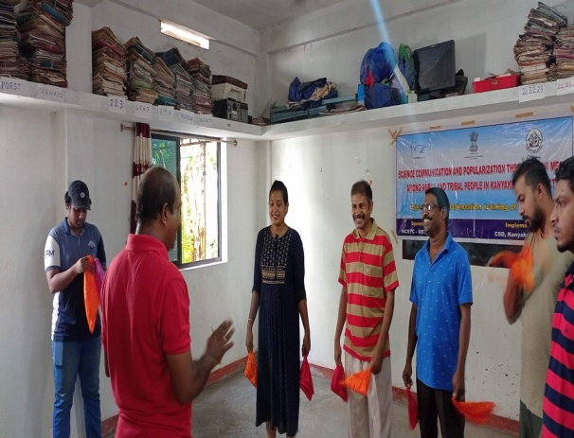
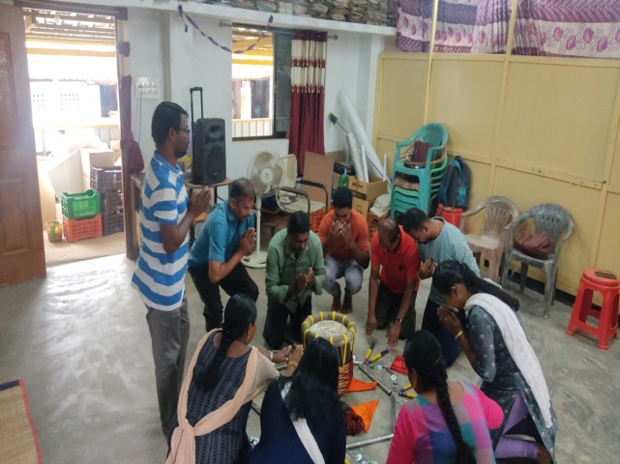

Orientation training given to artists.

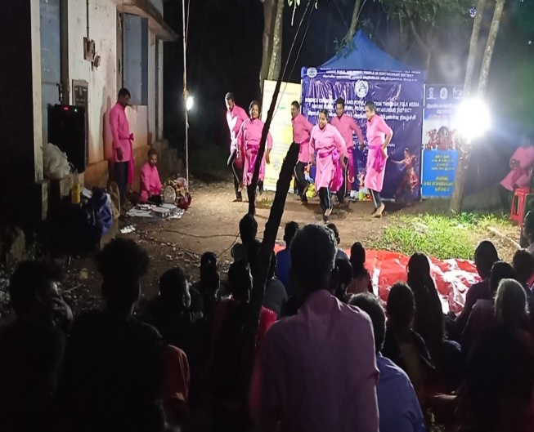
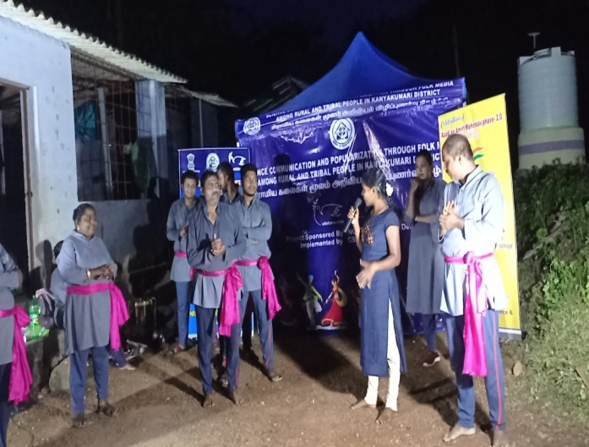
Programme conducted in rural and tribal areas.

- SHG promotion activities.
Organizing the rural women into group is one of the major activities of CSD. Under this programme both Kanyakumari and Tirunelveli Districts were covered. Regular meetings were conducted by our selected Animator in different locations of the district. The following table shows the details of the SHGs promoted.

Details of SHGs – Kanyakumari and Tirunelveli Districts
Name of the District | No. of SHGs | Total Savings | Bank Loan
Tirunelveli | 92 | 1,75,05,500 | 25,00,000
Kanyakumari | 83 | 4,75,12,000 | 1,22,00,000
Total | 169 | 6,50,17,500 | 1,47,00,000

- CSD-SHG Federation

CSD promoted the SHGs were federated and registered under the Tamil Nadu Societies Registration Act under the name of CSD-SHG Federation. At present the federation consisted of 11 members in Executive Committee and 230 members in General body. Both the general and executive committee meetings were conducted regularly for discussing the day to day activities of the SHGs. Programs such as future plan of Action, collection of savings, loan distribution and due collection, Bank Deposits, common programs were discussed. Programs like World AIDS Day, Women’s Day etc. were celebrated during this year.

- ICICI microfinance activities.

This is one of the major activities undertaken by CSD in extending microfinance to the SHGs working under the institution. Under the programme both the districts were covered. All the linkages were made to promote micro enterprises being developed by SHG women members.

Name of the District | No. of SHGs | Total loan disbursement
Kanyakumari | 27 | 1,91,35,000
Tirunelveli | 35 | 2,45,03,000
Total | 62 | 4,36,38,000

- Aatharavoo Kaigal- Helping Hand
Atharavoo Kaigal is another wing of CSD, formed by the Staff members of CSD and other well-wishers of the community. The main objective of the forum is to help the PLHAs, HIV affected and economically weaker sections of the society. These beneficiaries were selected from the SHGs of the respective villages. During the financial year the following assistances were distributed to the eligible candidates.
- Distribution of note books and uniforms to 3deserving and orphan students of the targeted areas.
- Nos. of Widows from the BPL were provided with financial support for promoting their business for income generation.
- Provided Economic and livelihood help to PLHIVs and HRGs.

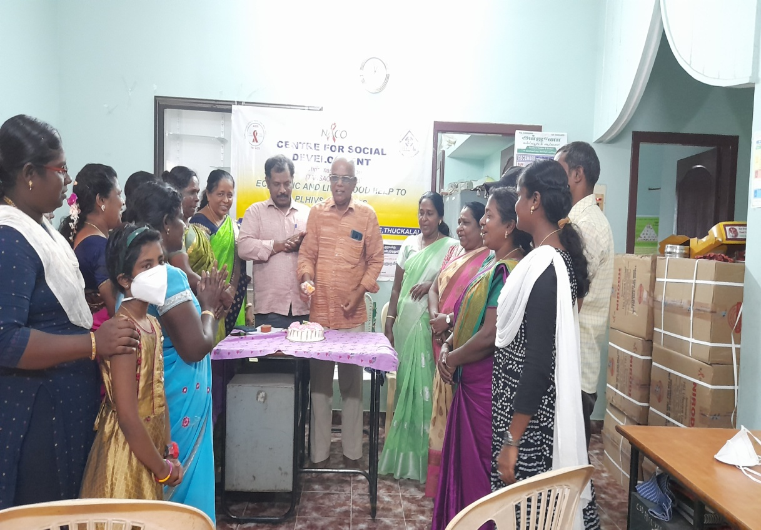

- Pottery Resource Centre at Thalakulam

The resource centre at Thalakulam has done remarkable research activities related to development of pottery. Some of the innovative activities carried out during the years were listed as follows:

- This centre has been utilized for extending training to the potters as well as entrepreneurs who are willing to establish sustainable pottery units.
- Clay composition of different nature has been tested for fabricating quality products.

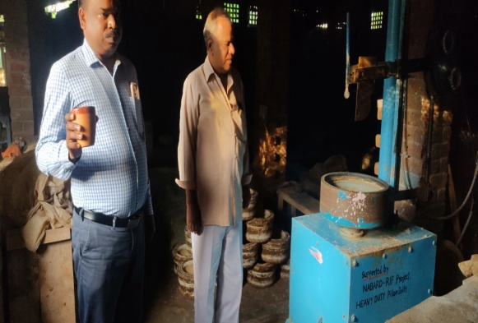
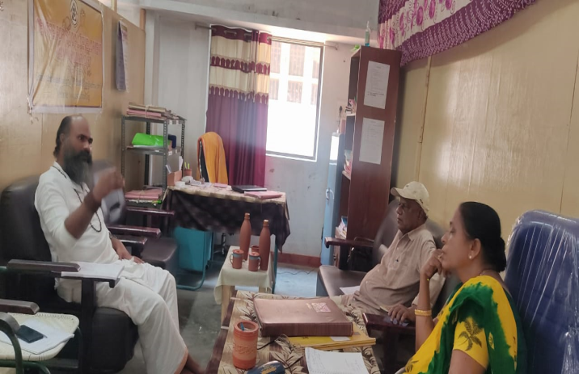

- CSD’s Other General Activities

In addition to the socio economic empowerment activity CSD is concentrating social service activities to the target people is also given importance. So many social service activities promoted by Govt. schemes had been availed to target people through mobilizing the SHGs to negotiate with the respective departments. The following were the important social activities made for this financial year in Kanyakumari and Tirunelveli Districts.
- Arranging Pension for Widows and aged persons.
- Arranging to get Ration Card.
- Seedlings for planting trees.
- Awareness about hygienic and diseases.
- Quit plastics and save our earth.
- Conducted exposure visit to the school, college students and vocational
trainees.
Independence Day and Republic day Celebration
CSD was celebrated Independence Day and Republic day Celebration in our Thalakulam Field Office.

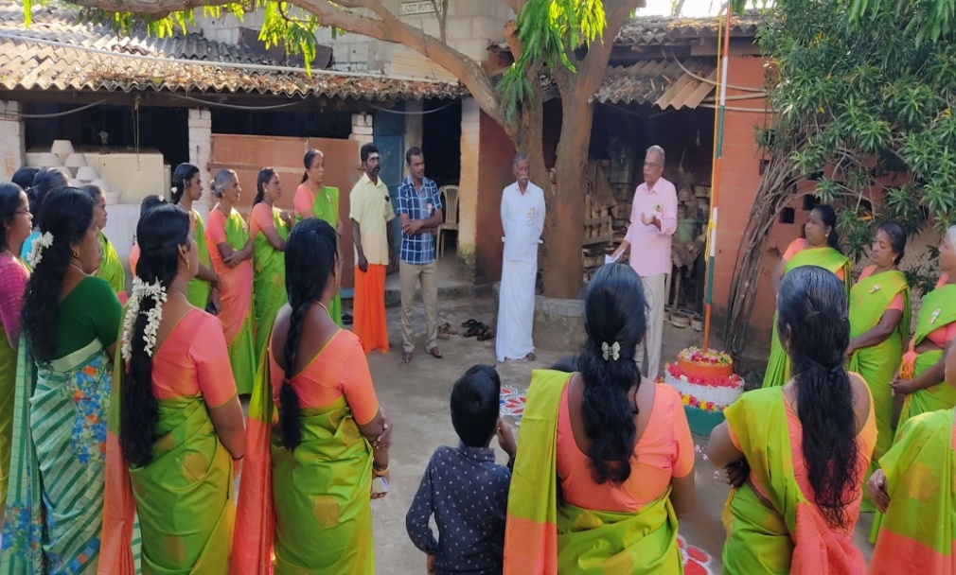
Republic day celebration at Thalakulam

Annual General Body Meeting.
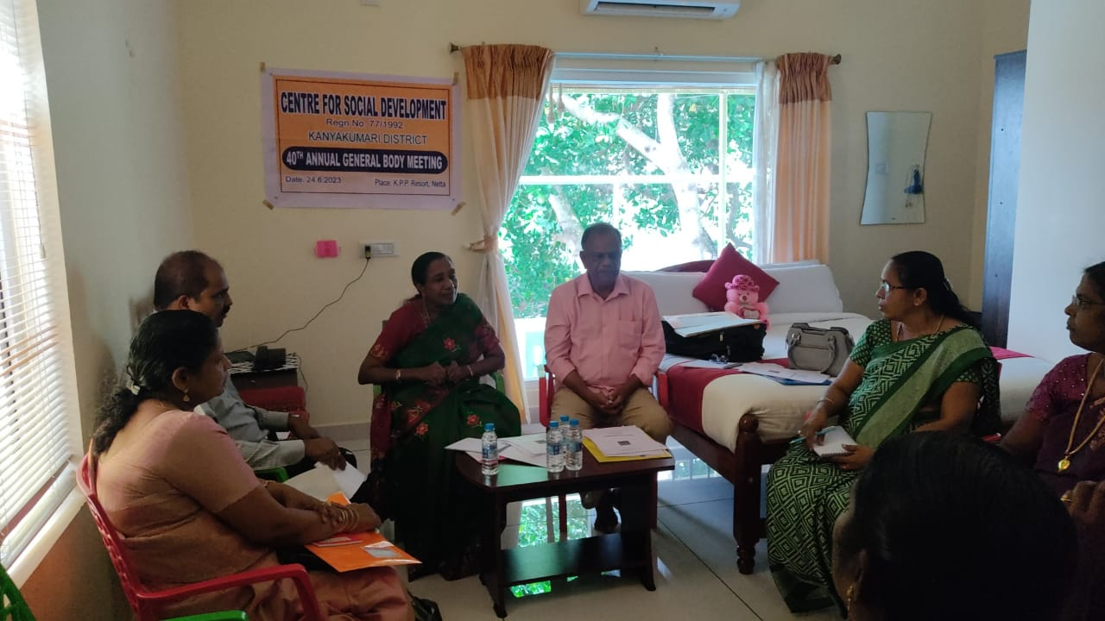

General Body Meeting
40th Annual general body meeting was conducted at K.P. P.Resort, Netta on 24.6.2023. The Annual report and Audited report were discussed in the meeting.

CSD’s G.B. Members List

S.No | Name of Members | Address | Occupation | Position in the Board
1. | Dr.A. Anandhy | 23D/10-4A, Grace Near High land Avenue,  Scott Nager, Nagercoil. | Lecturer | President
2. | Dr.P.Bagavatheeswaran | Kulala Street,  Thirunainarkurichi, Ammandivilai Post,  K.K.Dist. | Ceramic Consultant | Secretary
3. | Mrs. R. Baby Leela Bai | Kadanthancode,  Kuzhithurai P.O.  K.K.Dist | Project Co-ordinator | Treasurer
4 | Mrs.B. Sunanda Gnana Bai | Prem Illam  Kadanthancode  Kuzhithurai P.O  Kanyakumari District,  Pin 629 163. | Bank Manager(Rtd.) | G.B.Member
5 | Mrs.G. GnanaSelvi | PuthuvilaiVeedu,  Kanjampuram P.O,  Kanyakumari District | Teacher | G.B.Member
6 | Mr.B.Karthik | 11/32A Kulala Street,  Thirunainarkurichi,  Ammandivilai 629 204,  K.K.district, Tamil Nadu | Asst. Director | G.B. Member
7 | Dr.S. Sreeji | 136 S.J. Bhawan,  Kadanthancode  Pacode  Kuzhithurai 629 163,  K.K.Dist, T.N. | Lecturer | G.B. Member

Note: All the General Body members of the organization are honorary and they are not receiving any remuneration from the organization.

Consolidated Financial Status
Assets & Liabilities of the year 2023-2024
Liabilities | Amount | Assets | Amount
Capital Fund | 50,47,054.50 | Cash in Hand & Bank | 66,322.82
Liabilities & Advance A/c | 25,68,977.96 | Fixed Assets | 50,09,560.00
 |  | Deposits & Advance | 1,38,357.00
 |  | TDS | 2,80,454.16
 |  | Grant Receivable | 21,21,338.48
 | 76,16,032.46 | Total | 76,16,032.46
Income & Expenditure for the year 2023-2024
Income | Amount | Expenditure | Amount
Grant | 26,93,944.27 | Program Expenses | 76,56,632.26
Others | 12,22,484.00 | Depreciation | 7,33,062.00
Interest | 5,945.00 | Grant receivable written off | 1.65
Grant Receivable | 13,62,933.40
Expenditure over income | 31,04,392.24
Total | 83,89,695.91 | Total | 83,89,695.91
,

Conclusion
Our institution’s activities are going on well and progressively increasing. All our activities are technology based and Charity Oriented. We are having well experienced experts in different fields and also close contact with most of the research and Training institute of the country. In future our institution is planning to incorporate with more funding agencies and well-wishers and extending our working area with charitable nature and development programs for poor people and depressed communities and to achieve our goal by the GRACE OF GOD.

Thank you.

